Non-Functional Testing:

*Type of Testing  
In general, there are three testing types  
-Functional  
-Non - Functional  
-Maintenance

*What is Non-functional Testing?

Under these types of testing, you have multiple TESTING Level's, but usually, people call them as Testing Types. You may find some difference in the above classification in different books and reference materials.

The above list is not the complete as there are more than 100 Types of Testing and counting. No need to worry, you will pick them up as you age in the testing industry. Also, note that not all testing types apply to all projects but depend on nature & scope of the project. More on this in a later tutorial.

*Non-functional Testing Types:

Performance Testing  
Load Testing  
Fail over Testing  
Security Testing  
Compatibility Testing  
Usability Testing  
Stress Testing  
Maintainability Testing  
Scalability Testing  
Volume Testing  
Security Testing  
Disaster Recovery Testing  
Compliance Testing  
Usability Testing  
Portability Testing  
Efficiency Testing  
Reliability Testing  
Baseline Testing  
Endurance Testing  
Documentation Testing  
Recovery Testing  
Internationalization Testing  
Localization Testing

[#Non_functional](https://www.facebook.com/hashtag/non_functional?source=feed_text&epa=HASHTAG) [#Software_Testing](https://www.facebook.com/hashtag/software_testing?source=feed_text&epa=HASHTAG) [#Testing_Types](https://www.facebook.com/hashtag/testing_types?source=feed_text&epa=HASHTAG)

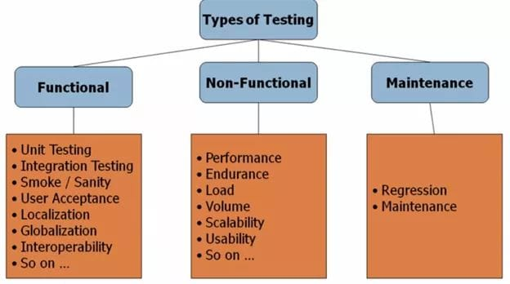

Top of Form

Bottom of Form